# Decree 103/M-DAG/PER/12/2015 – English translation

Importance of the legislation:

1. that in order to boost national competitiveness, it is necessary to **simplify the licensing** trade, particularly export and import rice
2. that the provisions on the export and import of rice as stipulated in the regulations of trade ministers number **19 / M-DAG / PER / 3/2014** concerning the provision of export and import of rice is considered to be **irrelevant**
3. Based on the considerations referred to in letter b, it is necessary to revoke the trade ministerial decree number 19 / M-DAG / PER / 3/2014 about the conditions of export and import of rice and set back the provision of export and import rice
4. Based on the considerations as meant in letters a, b, and c, need to establish rules of trade ministers on conditions of export and import rice

* **So basically, this provision replaces decree 19 / M-DAG / PER / 3/2014**

Article 1

2. The export of rice is rice issuing activities of the customs area

6. Rice exporters are companies performing rice export activities

8. The export approval is the approval that is used as a license to export rice

10. Recommendation is a letter issued by the minister or appointed official, contains a technical explanation of the rice to be exported or imported

11. The technical verification is the research and technical inspection of imported goods carried by the surveyor

12. surveyor survey company that is authorized to perform verification or technical surveillance of imported goods

13. The label is any description of the rice in the form of images, text, deduanya combination, or other forms containing information about the product and information businesses as well as other information, are included in the goods, put in, affixed / attached to the goods, printed on goods, and / or are part of the packaging of goods

14. The food tara logo is a sign indicating that a safe food packaging used for food

🡪 **so it seems that special rice packaging is mandatory only for imported good, since no mention of exports.**

Article 2

1. **The type of rice that can be exported as listed in Annex I** which is an integral part of this ministerial regulation

Article 3

**the determination of the amount of rice that can be exported** and imported as referred to in Article 2 are determined and **agreed upon in the meeting of coordination between ministries / non-ministerial government agencies**

Article 4

1. Exports of rice can only be done if the supply of rice in the country has exceeded the needs
2. The export of rice as referred to in paragraph (1) for other types of rice, which are not produced through organic farming systems:
3. with maximum breakage level of 5% (five percent) can be done by state-owned enterprises, region-owned enterprises or private companies;
4. with maximum breakage level of 25% can only be done by a public company Bulog
5. rice exports for this kind of black glutinous rice and rice produced through organic farming systems with maximum breakage level of 25% (twenty five percent), can be done at any time by the company as described in paragraph (2) letter a

Type of rice that can be exported: 1006 30 30 00, 1006 30 99 00

Article 5

1. The export of rice by the companies referred to in paragraph 4 (2) letter a and paragraph (3) can **only be done after receiving an export approval from the minister with regard to the recommendation of the minister who held government affairs in agriculture or a designated official**
2. Export of rice by the **general company Bulog** as referred to in Article 4 paragraph (2) letter b can only be done after receiving an **export approval** from the minister based on an agreement coordinating meeting ministerial level for the economy
3. The Minister mandates the issuance of export approval referred to in paragraph (1) to the director-general

Article 6

1. To obtain export approval referred to in Article 5 paragraph (1) and (2), the company must submit an application electronically to the minister in this case the director-general, accompanied by:

a. Trading license (original);

b. Registration of Companies (TDP);

c. Organic certificate of organic certification bodies that have been verified by the Organic Food Authority competence or accredited by the National Accreditation Committee (KAN) or which has been recognized internationally, for the export of rice produced melahui organic farming systems as referred to in Article 4 paragraph (3);

d. Recommendation of the minister who held government affairs in agriculture or appointed official, the export of rice as referred to in Article 4 paragraph (2) letter a and paragraph (3); and

e. Confirmation of orders from potential buyers abroad

3. To request approval for the export of rice as referred to in Article 4 paragraph (2) letter a, director-general on behalf of the minister issue export approval which applies to each shipment

4. To request approval for the export of rice as referred to in Article 4 paragraph (2) b, the minister issue export approval is valid for 3 months

5. To request approval for the export of rice as referred to in Article 4 paragraph (3), the director-general on behalf of the minister issue export approval is valid for 6 months

6. The export approval referred to in paragraph (3), (4) and (5) shall be issued no later than 3 working days from receipt of the application is complete and correct

Article 7

Persutujuan export as referred to in Article 6 paragraph (6) containing data and / or information at least on:

a. number and date of recommendation

b. the name and address of the exporter;

c. types of rice;

d. volume of rice;

e. weight packaging;

f. brand packaging;

g. Tariff heading / HS;

h. breakage level;

i. loading port;

j. country of destination;

k. number and date of issuance of export approvals;

l. the validity period of export approval

Article 8

Rice referred to in Article 4 to be exported must be packed in with the included information regarding:

a. company identity;

b. Produced in Indonesia;

c. Level of Broken

Article 31

label referred to in paragraph (1) shall at least include information on:

a. types of rice;

b. weight packaging;

c. breakage level;

d. country of origin;

e. the name and address of the exporter;

f. the name and address of the importer

**🡪 so labels on exported goods as well, probably**

Article 36

1. Recommendations exports became an inseparable unity with the export approval

Article 37

1. Approval of exports is used as customs documents for clearing purposes in the field of export

Article 38

1. Each rice exporter and importer must submit a report on the implementation of the export and import of rice, whether realized or unrealized, electronically via http: // ... to the minister with a copy to:

list of people (Ministers, directors, etc.)

1. The report referred to in paragraph (1) shall be submitted every month by the 15th of the following month
2. The report referred to in paragraph (1) shall be equipped with a control card realization of export and import are submitted electronically to the director-general no later than 15 days after the date of expiry of the approval of export and import approval
3. in the event of circumstances that resulted forced the electronic system via http: // ... does not work, the reporting referred to in paragraph (1) shall be submitted manually

Article 40

Companies that do not carry out the reporting obligations referred to in Article 38 as (2) times, sanctioned the suspension of the application for approval or approval of export to import rice for 6 months

Article 41

approval of export and import approval is revoked if the company:

a. packaging as it violates the provisions;

b. it violates the provisions of the labels referred to in Article 31;

d. proven to change, add and / or replace the content of the approval to export or import approval;

e. meyampaikan proven data and / or incorrect information after approval to export or import persutjuan issued;

f. exporting or importing rice type and / or amount is not pursuant to the agreement contained in the export and import approval;

g. offenses based on the assessment and recommendations relevant technical agencies;

h. convicted for violations of criminal offenses relating to the misuse of rice it exports and / or imported

Article 43

Companies that have been subject to sanctions revocation of approval for export or import approval referred to in Article 41 can only reapply for approval to export or import approval after 1 year from the date of revocation

Article 47

Companies engaged in the export of rice and / or import of rice is not in accordance with provisions in this ministerial regulation sanctioned in accordance with the customs and / or other relevant provisions of laws and regulations

Article 50

The provisions in this ministerial regulation does not apply to the export or import of rice which is:

a. goods for research and technological development;

b. goods crossing borders with certain customs value in accordance with the provisions of laws and regulations in the field of customs

Article 53

exemption from the provisions stipulated in the ministerial decree is subject to approval of the minister after receiving input from relevant agencies

article 55

during the ministerial regulation comes into force, trade ministerial decree number ...3/2014 on the provision of import and export of rice, revoked and declared invalid

* meaning that end date = entry into force date minus 1 day

Article 56

The ministerial regulation came into force on January 1, 2016

Type of rice that can be exported: 1006 30 30 00, 1006 30 99 00

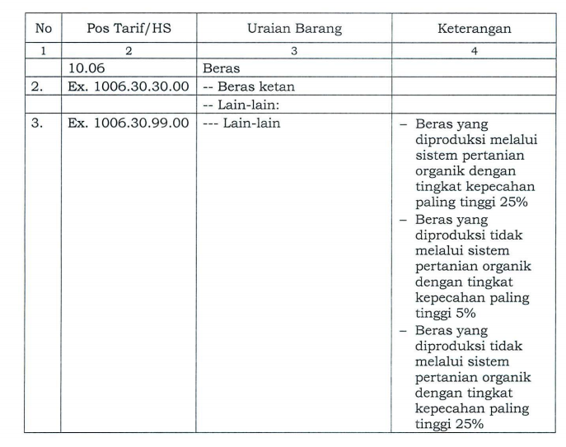

|  |  |  |
| --- | --- | --- |
|  |  |  |
| 1006 | rice |  |
| Ex 1006.30.30.00 | Glutinous rice  -- other |  |
| Ex 1006.30.99.00 | --- other | * rice produced through organic farming systems with maximum breakage level of 25% * rice produced not through organic farming systems with maximum breakage level of 5% * rice produced not through organic farming systems with maximum breakage level of 25% |